OnTrack
Timesheet & Project Cost Tracking Online
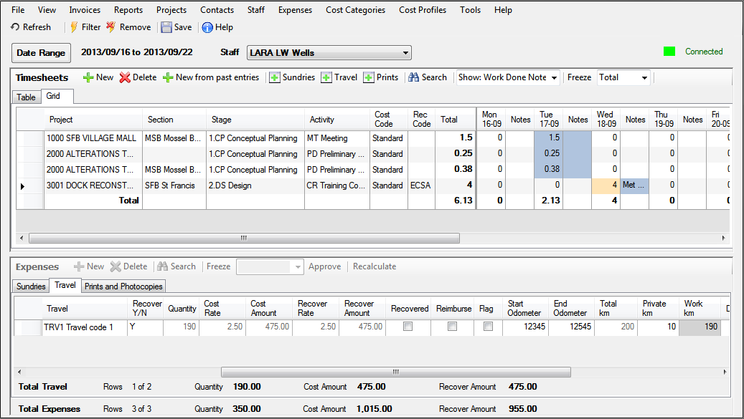
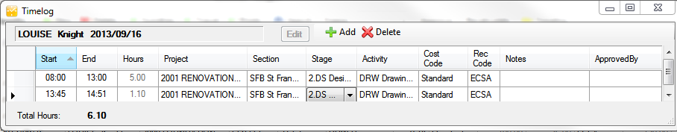

The OnTrack solution was developed for professionals in the built environment and is used by small and large companies throughout southern Africa. This project cost program can be used to budget, record and ort project costs & income including staff time and disbursement costs whether the work is time-based or fee-based.

OnTrack can be used to prepare budgets for projects costs and income, and to keep track of and report on all project costs and income including:

staff time costs travel costs sundry expenses

print & photocopy costs invoiced income

Reports include recoverable (billable) time that can be used to help prepare accurate invoices, and projects' costs and profitability.
Features

- simple and easy to install & use
- user defined sections and activities
- predefined & ad hoc reports
- reports on invoice status
- totals on each screen
- multiple rates per staff member
- optional employee overhead factors
Benefits

- informed, effective management decision-making
- more accurate tendering
- immediate access to project costs
- project budget comparisons & live monitoring
- wide range of project reports
- staff experience recorded automatically
- secure data
- single database
- more accurate invoicing
- web access for timesheet capture anywhere any time

Detailed information

OnTrack Interface

- Timesheet users default to the familiar timesheet Grid View and OnTrack administrators to the Table View with many options to filter data for editing and reporting.
- Timesheets and Expenses on one viewing pane or viewed separately.
- Interface customisable for user preferences
- Projects, cost categories, expense codes and cost and recoverable rate codes are selected from drop-down lists.
- One-click addition of expenses with timesheet details
- Notes included for timesheets and expenses
- Expenses – Travel includes odometer reading for car travel which calculates mileage – office and private can be captured
- Expenses include an option to select to have expense reimbursed to Timesheets User.
- Upload documents to relevant expense transaction.
- Timesheets and Expenses entries can be locked for Timesheets Users as Approved by designated Power Users and OnTrack Administrators.
- Timesheets and Expense rows can be selected and recalculated, including retrospective entries, when cost and/or recoverable rates are added or amended.
- All screens include a search option, comprehensive filter options as well as totals for various columns. These filtered totals allow for quick and real-time project management information.
- Reallocate function allows OnTrack Administrators to reallocate Projects, Sections, Stages/Phases and Activities to a different code. This can be done for a filtered subset of Timesheets or Expenses. This is useful when moving from a temporary or provisional code to a final code or when more detailed reporting is beneficial

Web interface
Members of staff not on the network or who prefer the browser environment can fill in timesheets and disbursements directly into the database using the online interface. Documents, for example, invoices, can be uploaded against the transaction for which they were raised.

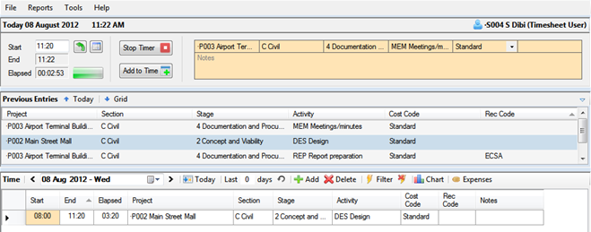
Timelog
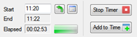
The free Timelog module is an alternative way for users to capture time and expenses dynamically in a timed environment with pop-up reminder.
Timelog allows Activities with the relevant cost and recoverable codes to be timed and entered into the Time Grid on completion of the task. One of the primary functions of the program is to remind users at user specified intervals to check and update their Timelog for the day. Both Time and Expenses can be captured quickly and easily in Timelog.

Dashboard
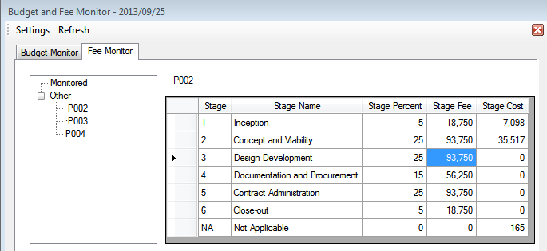
Dashboard is a free management tool. It allows partners and/or managers to monitor project expenses, budgets and related information and present the information in a visual format. The tool can be kept running in your computer system tray to monitor your projects and warn you if any projects expenses exceed a predefined percentage of your budget. Dashboard views can be generated and saved for easy retrieval and monitoring.
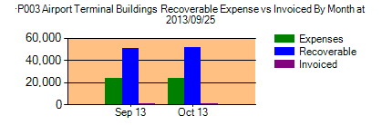
The key benefits are constant monitoring of project expenses, the ability to generate, format and save graphs in various formats within an intuitive and familiar windows system interface.
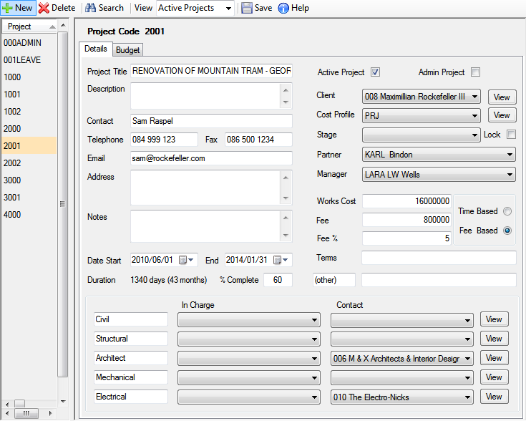
Projects
- Project Sections, Stages, Activities and Expenses can be restricted to a Cost Profile for more accurate data capture, monitoring and reporting
- Set/Lock a project to a Stage for simpler capturing
- Admin project reporting separated out
- Works Cost and Time or Fee basis captured. Used for the Profitability report and Dashboard monitoring
- Contact link for Client
- Partner and/or Manager allocation for reporting purposes & Dashboard monitoring
- Allocate Contacts and/or responsible staff for different aspects of a project
- Can be made Inactive once completed. Data retained for reporting.
- Adding and editing function can be given to a team leader or projects administrator

Project Budgets
- Budgets can be built up from Staff time and Expenses and can be allocated at the level of Section (Department), Stage (Phase) and/or Activity.
- Staff time can optionally be built up from individuals’ staff time and Expenses from a Sundries, Travel and Prints amount.
- Team leaders, Directors and/or Managers can be given access to create Project Budgets (with or without visible rates)

Cost Categories
- Sections (Departments), Stages (Phases) and Activities
- Can optionally hide columns which are irrelevant for the company under Tools
- Can be made active or inactive

Expenses
- Include cost, recoverable rates and mark-up factor.
- Can be zero rated to allow user to enter amount (recoverable amount then cost amount * mark-up factor)
- Can be made active or inactive

Cost Profiles
Different types of project attract different Sections, Stages and Activities as well as expenses specific to that type of project.
- Create profiles for each type of project
- Allocate Projects to a particular Cost Profile in order to restrict user entries for timesheets and expenses
- Activities may be entered per Stage

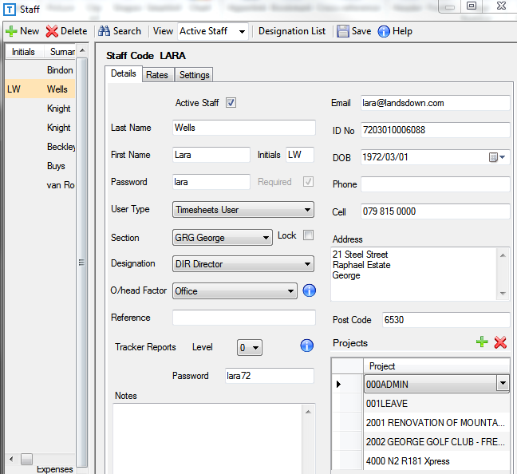
Staff
- Unlimited user-defined cost and recoverable rates
- Rates particular to date ranges or contracts
- Three users types are available – OnTrack Administrator (full functionality), Power Timesheets user (captures timesheets & expenses for other users or manages staff and approves timesheets) and Timesheets user
- Option to allocate staff an overhead factor which adjusts all amounts accordingly to include overhead expenses in the rate
- Option to allocate or lock staff to a Section for easier, more accurate capturing
- Option to restrict staff to projects they are working on for accurate timesheet and expense capture
- Staff may be given a password with which to access particular reports.
- Staff can be designated active or inactive

- In order to assist OnTrack Administrators with time consuming data capture and to allow additional options for team leaders and managers, settings options for individual members of staff now include:
  - Expenses Options
    - option to display cost amounts (selected by default)
    - option to display both cost and recoverable amounts
  - Menu Options
    - Expense codes - add and edit
    - Invoices - add and edit – for accounts department staff
    - Contacts – read only (selected by default) or add & edit – for reception staff and/or PA’s
    - Staff Details – add and edit (rates hidden or displayed) – for human resources staff
    - Cost Categories – add and edit
    - Cost Profiles – add and edit
    - Project Details – add and edit (amounts hidden or displayed)
    - Project Budgets – add and edit (hours only or displayed rates & amounts) – for managers
  - Power User Options
    - Timesheets – option to display rates, cost and recoverable amounts
    - Staff details – option to display rates only for allocated power user’s staff
    - Option to restrict power user access to particular members of staff.
    - Option to allow power users to approve timesheets and expenses – for managers
  - Dashboard Level
    - Allows for specified access to projects in the Dashboard module. – for partners, directors and/or managers
- User type, Reports access and passwords can only be entered and changed by an OnTrack Administrator to ensure security of sensitive information.
- Subcontractors and consultants can be added to the staff table and their time and expenses are also tracked against projects.
- Any administrators for whom time and expenses are not captured are free on the system.

Contacts
- All users have non-editing access to Contacts selected by default Categorised and searchable by category, e.g. Clients, Architects, Civil, Electrical etc. All former Client entries are imported into Contacts as Clients by default on upgrading data
- Categories are customisable
- Adding and editing function can be given to an administrator, receptionist or PA.

Invoices
- Unlimited entries for description and amounts available for fee, recoverable and cost income entries
- Defaults to the projects’ allocated client when the project is selected.
- Most fields, including invoice number and client are available for filtering.
- Adding and editing function can be given to a bookkeeper or accounts administrator.

Reports
The power of the OnTrack program is in the reporting function. There is a comprehensive list of reports available. Should a report not be available that would be useful for your company, please email your request. Most report creation is free.
- Reporting can be done on active and inactive projects, staff and contacts.
- Reports can be allocated an access level. Any user can be given password access to an allocated level of report.
- Customisable
  - Optionally hide columns
  - Logos can be added as headers or footers
  - Customise fonts and column widths under OnTrack Reports > Edit
  - Odometer readings for office and private mileage
- Functional Timesheet user reports
- All reports can be printed to Printer, to Preview (and then to hardcopy, PDF or RTF file), to Word or to Excel.
- Reports may be run by any user with a password.
- Reports can be given levels and made available accordingly.

Help
- Comprehensive help is available with each screen and online tutorials are available.

Security
Our hosted data security is prioritised and the OnTrack database for each client is hosted securely on our site, which is backed up automatically. For more detailed information on our security, please contact us.

OnTrack Information Sheet 2013-09-26 LK

